The Social Sciences
Minds On… Match the picture with the ology by drawing a line
Anthropology Psychology Sociology

Anthropology
- Studies the origins, development, beliefs and customs of the human
species and can be divided into 2 types
i) ______________________anthropology & ii) ___________________ anthropology
- _____________________ are used to piece together the development of human society(s).
- It involves the study of different cultures, current and ancient
NOTE ____________________________________.
- Information gained is used ______________________________________ about human behaviour.
- Spend a lot of time ____________________________________________________.
Psychology
- studies the behaviour, mind and personality _______________________________.
- goals of psychology are to observe, describe, understand, predict and control ____________________________ (modify behaviour, motive etc.).
- psychology focuses on the individual rather than the group.
- many modern psychologists believe that most human behaviour _______________
________________________________.
Sociology
- is the study of human _________________________________________ as a whole.
- the behaviour of the group is used to explain the behaviour of the individual.
- sociologists examine _____________________________________________________
- _______________________________________________________ but in a shorter time period than an anthropologist.
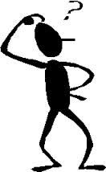
different perspectives… different questions…
- these are all behavioural sciences they are ___________________ in some ways and ________________ in others, sometimes the differences are subtle.
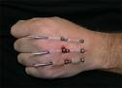
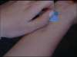
- however, the _____________________________ lead the researchers to ask different types of questions.

example…
- Topic > cutting
  - The psychologist might ask: ________________________________________________
___________________________________________________________________________
  - The sociologist might ask: __________________________________________________
___________________________________________________________________________
  - The anthropologist might ask: ______________________________________________
___________________________________________________________________________

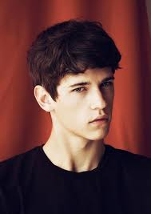
What is a question that you have about human behaviour?
_____________________________________________________________________________
_____________________________________________________________________________
_____________________________________________________________________________
__________________________________________________________________________________________

