Psychology Theories Ways of Understanding & Explaining Behaviour

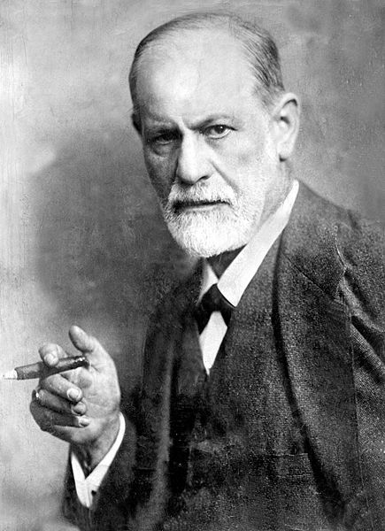
The Father of Psychology
- Sigmund Freud (1856-1923) is
known as the father of psychology.

- Freud established a branch of
psychology known as
__________________________________.

- He is the father of __________________ therapy
and his work is still considered very influential.
id
primitive drives
ego
reality based
superego
conscience

Psychoanalysis
- founded by Sigmund __________________
- viewed human behaviour as being driven by the ____________________ &__________________workings of
the mind
- felt the mind was controlled by three main forces
- believes you can uncover these subconscious or unconscious thoughts or urges by using free association, dream analysis, hypnosis etc.
- humans ruled by forces or drives https://www.youtube.com/watch?v=MxU5M2VVZqQ
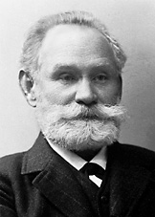
Behaviourism http://www.brainpop.com/games/pavlovsdog/
- one of the founders is Ivan __________________ (classical conditioning)
- this is a theory about learning and conditioning
- he felt that actions and responses that can be observed should be
studied or in other words______________________________________________
- humans respond to stimulus s > response r
(objects or events) (behaviour or action)
relationship

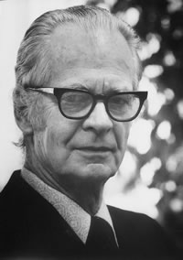
- all behaviours are ______________________ to some form of environmental stimuli

- B.F. Skinner further looked at how behaviour is shaped
based on rewards or ______________________ for the behaviour

- Humans respond to stimulus with behaviour and respond
to reinforcements with _____________________behaviour

https://www.youtube.com/watch?v=teLoNYvOf90

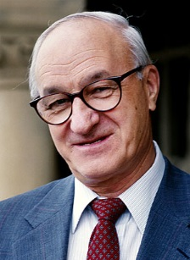
Social Learning Theory https://www.youtube.com/watch?v=zerCK0lRjp8
- one of the founders is _______________________ (modelling)

- felt that learning occurs through _____________________________

________________________________________________________________

- this learning can be maintained through __________________ (has its roots in behaviourism) which means that we can __________________ __________________ that are being learned by modelling desired behaviours and then rewarding them

- goes beyond behaviourism and recognizes that the ____________________________
of learning is important and that humans influence their environment as well as being moulded by it

- __________________ factors like beliefs and attitudes affect learning, behavioural factors include the response to a given situation – eg. fail a test > anger / or fail a test > work harder

- __________________ factors include the modelling of parents, teachers, and peers

- humans are shaped by their interactions and particularly by __________________ _____________________ through observation of behaviour and whether or not the specific behaviours are______________________

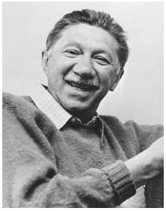
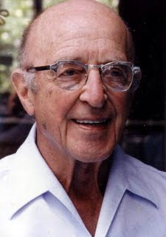
Humanism
- Carl _____________________ Abram _____________________
- look at the __________________quality of human beings and their potential for personal growth
- feel that people can take control of their lives and are not just ruled by drives and emotions (Psychoanalysts) or by the environment and stimuli (Behaviourists)

- humans have __________________ but humans make choices regarding how to best satisfy those needs
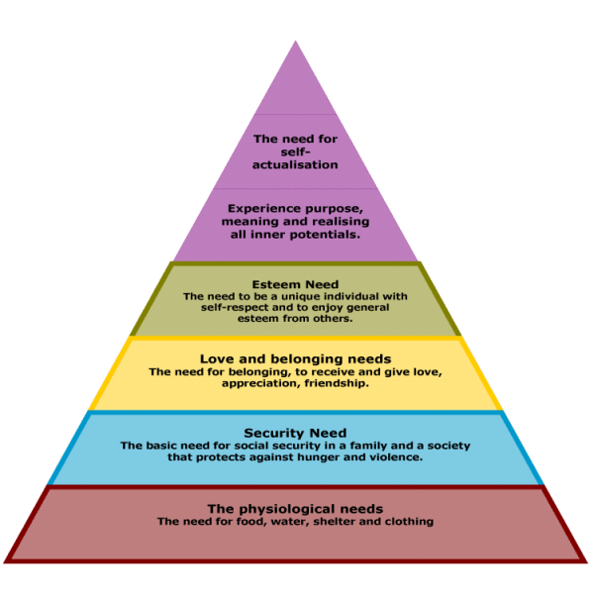

Universal Hierarchy of Needs

Cognitive Psychology https://www.youtube.com/watch?v=GX1Tc8E8eck&safe=active

- look at the __________________ and mental __________________ involving memory/ learning/ thinking
- we can monitor the brain to see what part is active when we talk, laugh, watch tv etc. technology has improved this area of study immensely ex. MRIs
- study the connections between _________________________________________
___________________________________________________________________________

- humans think and that thinking can be studied but it can also be shaped

