Human Vs. Neanderthal Skulls
- Neanderthals are estimated to have disappeared about 30,000 years ago, possibly as a result of territorial encroachment from homo sapiens.
- As modern humans spread out from Africa they encountered other hominins such as Homo neanderthalensis and the Denisova hominin, who may have evolved from populations of Homo erectus. The nature of interaction between early humans and these sister species has been a long standing source of controversy, the question being whether humans replaced these earlier species or whether they were in fact similar enough to interbreed, in which case these earlier populations may have contributed genetic material - and immunity - to modern humans [Wood 2009].

- The difference between Homo sapiens and their immediate successors Homo sapiens sapiens can be described by a number of anatomical features. Homo sapiens had robust skeletons, from a more physical life, rather than a reliance on technology. Homo sapiens have more visible brow ridges, less vertical foreheads and less prominent chins.
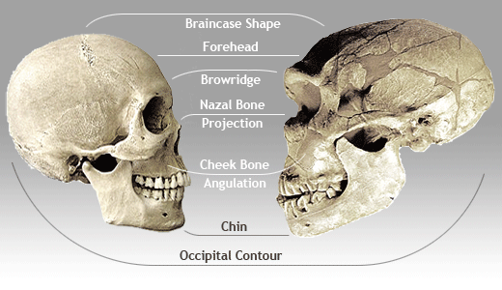

Skull Vault
- The encasing of the modern human brain is slightly shorter (horizontally) than that of the Neanderthal brain.

Brow
- The brow ridges of the Neanderthal was large and pronounced, while a homo sapiens cranium is slighter. The foreheads of modern humans are rounder and higher than that of the Neanderthal.

Jaw
- Neanderthals had receding chins, forward-jutting jaw and large front teeth. Homo sapiens have a slightly protruding chin and relatively smaller front teeth and jaw.

