Useful websites for the DSM V assignment include
www.allpsych.com
www.cmha.ca

What is Comic Life?

Comic Life is an award winning application for creating not just comics (obviously), but also annotated images, dynamic photo albums, greeting cards, scrap books, story books, and instruction guides and brochures. Comic Life allows you to create page layouts with boxes for images and text. Styles can be applied to create just about any type of ‘feel’ for your document. Captions can be created with tails in order to have thought balloons, speech boxes or just additional annotations. Filters are available to turn your digital images into a variety of hand drawn looking graphics to enhance the comic appearance of your work.

To access Comic Life at school
go to desktop
choose student applications folder
choose the language arts folder

choose comic life

The Comic Life Interface
Comic Life gives you a clean and simple interface to use when creating your comic masterpiece. The main window is divided into four major panes.
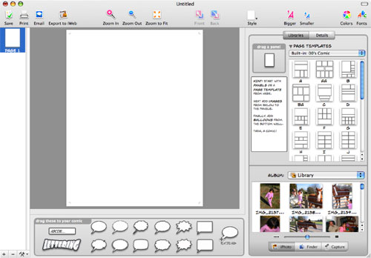
The left pane shows your pages and allows you to manage them by adding, removing or re-arranging them. The right side of the window has libraries and settings for page layouts and templates, and also an interface to browse your iPhoto library, albums, and any folder on your hard drive or mounted disks. Use the built-in image capture system in conjunction with a connected/built-in camera.
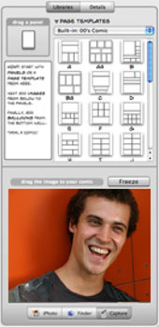
The bottom section of the window has a collection of text containers to create annotations, speech and thought bubbles in a variety of styles.
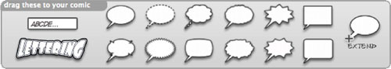
The filters you apply to the text elements allow you to create eye-popping effects.
The center pane is where you will complete all of your layout and text entry. It is the pasteboard (or work space) for your pages.

How to Create a Comic in Comic Life
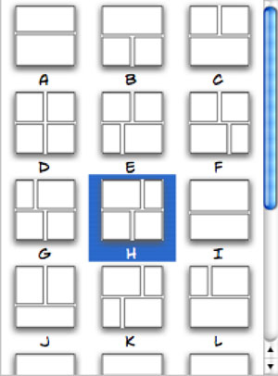
Creating a comic with Comic Life is a simple 5-step process.

- Select a template for your new page. There are over 200 templates in categories such as comics from the 40’s, 60’s and 80’s, manga, graphic novels, and euro comics. Or, you can create your own layout by dragging panels anywhere you want them.

- Add digital images from other disks or a connected digital camera. You can drag and drop images from the interface of Comic Life (from your Photo library or any connected disk), or you can drag items directly from the Finder into Comic Life.
Dragging an image onto a panel will put the image into the panel and crop it so the shortest dimension of the image matches the shortest dimension of the panel. You can adjust the panel size/shape separately from the image’s size.

- Select a style/filter for digital images. You can leave your images in their unfiltered state, but Comic Life's built-in filters and styles give you some very cool control over how 'comicy' your comic looks. If you don’t like the pre-defined styles, you can enter your own filter settings to get that perfect look.
Don’t overlook the fact that you can draw your own images (on the computer, or on paper and scan them in) and then include them in your comic once they are in a digital format.

- Add text containers and text. Just like almost everything else in Comic Life, adding text is a simple drag and drop process. The text containers at the bottom of the window provide you with different text presentations.
Drag a container into your page and enter your text. If you have a balloon selected, you can drag the tail to associate the speech or thought with a particular character in an image. Additional tails can be added for more than one speaker at a time. Other text containers have options for styles and effects to enhance the text. The controls allow you to stretch, scale, skew, colorize, outline, shade and too many other options to list. The pre-defined options are numerous and individual controls let you take them further.
Nothing says WOW like...

- Save (frequently) and export to your format of choice. Your export decisions will be based on what you intend to do with the comic when you’re done. Comic Life has several export options that allow you to share your work in digital or paper/printed form. The HTML export creates an interface that allows users to ‘flip’ through your comic page-by-page.

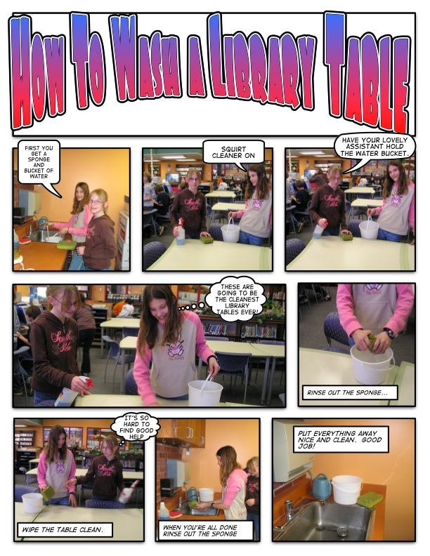
Examples

