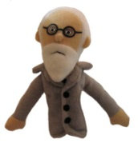
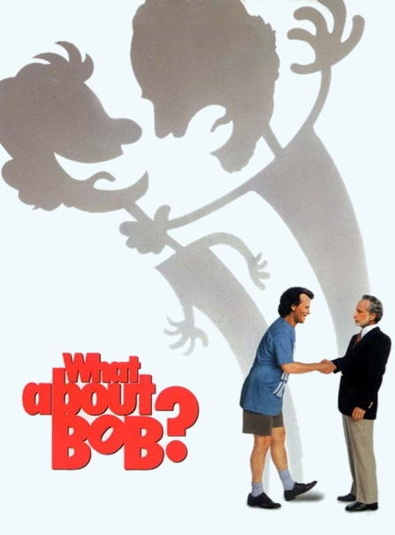
What about Bob? The Movie: Making the Treatment Connections
F.Y.I. Leo’s son Siggy is named after Sigmund Freud & Anna is named after Freud’s daughter.

16x to living room.
- In Chapter 1, if you had to categorize Bob Wiley’s illness with one of the DSMV categories which would it be? __________________________________________

- In Chapter 3, Bob is walking down the street repeating “I feel good, I feel wonderful…” Which type of therapy asks clients to rethink how they feel and change how they think through practice? _________________________________________
16x forward to family intro in office and “I have problems”.

- In Chapter 4 or 5, Bob is in Dr. Marvin’s office and he is explaining his troubles. Dr. Marvin proceeds to prompt him to “talk about moving” then “talk about weird”. Which type of therapy asks clients to simply talk about things, hoping to unearth some hidden information? __________________________________________________

In the same scene Dr. Marvin asks “What is the crisis, Bob? What is it you are truly afraid of?”. This is based on the therapy that views unconscious conflict, crisis or fears as the root of mental illness. The idea here is that if you resolve the unknown problem the difficulties clear up for the patient. This is also part of which type of therapy? ______________________________ after turrets scene forward 16x to book.

- Dr. Marvin then goes to the book shelf and pulls out his new bestselling book “Baby Steps”. In this book the goal is to set small reasonable goals and win small successes one step at a time. The idea behind this type of therapy is that if you experience something you are conditioned to be afraid of and instead are rewarded with some form of success, you will be able to recondition yourself into continuing without the same negative fears. This is part of ____________________________ therapy. Watch till Dr. Marvin tells Bob he is going on vacation then move to Chapter 6 scene with Leo.

- Bob meets the Marvin family at the cottage. Dr. Marvin is not happy to see Bob and does not want to treat him while he is on vacation. Instead he asks Bob to step outside and takes out his prescription pad. Bob assumes that Dr. Marvin is writing him a prescription for drugs. This is part of which type of therapy?_______________

- Dr. Marvin instead, writes on the pad, “take a vacation from my problems”. He is telling Bob to put his problems on the back burner so to speak or to temporarily cease thinking about them. This helps a client learn to control their fears. This is part of _________________________ therapy. Forward to Chapter 7

- In Chapter 7, Bob goes sailing with Anna. He is afraid to sail but decides to try anyway and succeeds by tying himself to the mast. This is a form of sensitization which is part of ________________________ therapy. He is rewarded by surviving and enjoying sailing. Watch to puppet therapy.

- In Chapter 8, Bob is with Siggy on the dock. He is starting to bond with Anna and Siggy. Watch to shower scene. Go past dinner, choking, storm, sleepover and morning show. Watch Leo Marvins’ family reaction to Bob. Leo apologizes and takes Bob on a car ride. During the car ride, Bob thinks they are doing therapy and he starts in with “wow some free associations from my infancy… a beach ball, a dog, a frog, a log, a poodle a doodle”. This is a technique used in _____________________________________.
Watch to the gate scene. Forward X32 to birthday party.

- Leo enters his surprise birthday party and sees Bob with his sister Lily and flips out. His friend another psychologist gives him a sedative and writes a prescription for an anti depressant. This is ________________________ therapy. Proceed to last chapter.

- By the end of the movie, Bob has been accepted into the Marvin family by Faye, Anna and Siggy and by Lily who he marries. This love and acceptance is one of the possible reasons for his wonderful recovery, although he attributes it to “death therapy”. This cure is part of the ________________________ therapy.

