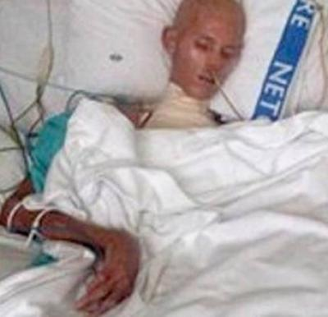
Victims of 'gay cure' camps reveal what really happens
From suicides to shock therapy, survivors of the horrific practices done in the name of 'cures' share their experiences
17 January 2014 | By Liam Johnson

Victims of 'pray the gay away' camps have shared disturbing accounts of their experiences.
Users of Reddit revealed what had happened to them and their family members and friends on the social website.
'I have an older friend who went to one because his father was disappointed in him for not being "normal",' one said.
'Apparently one of the tests involved taping electrical pads to his testicles and forcing him to watch gay porn. If he got an erection, then he was zapped.
'Worked so swell that he married a lady... Then divorced her... Because she was a lesbian... And he got a boyfriend... Yeah...'
Another user revealed one camp had used methods to brainwash victims into believing their sexuality was a result of a former trauma.
They said: ‘They tried to get him to think that he was gay because his biological father was abusive to him and his mother, or that he was mad at his adoptive father, or he never forged a close bond with his mother.
'They tried to see if he just wanted to be "different" to stand out, just all these odd scenarios.’
One user recounts how the camp they were sent to was actually disguised as something else completely.
‘Mine was officially billed as a church camp for unruly teenagers. It just so happened to largely rely on anti-gay therapy. There was a room for solitary reflection that I got sent to a lot,' he said.
'It was terrifying. I'd go for day long periods sitting in the room without food or water because I'd denied Jesus and refused to admit to a problem I didn't have.’
But even if that camp was starving teens for being gay, the same Redditor added: ‘I walked in on a camper hooking up with a counsellor of the same sex at the obstacle course once.’
Many of the 'pray the gay away' camps, where many of them segregate boys and girls away from each other, often have the opposite effect to what they are trying to achieve. Many of them end up in bed together.
But it is two of the most horrific stories that prove why these camps should not exist.
One said: 'My friends cousin was sent away to one of these camps. After several pleas to her parents to leave and that it wasn't working and making her miserable and develop a sense of self loathing she was forced to finish the program, still gay.
'She committed suicide a month later and in her letter she wrote, "Mom, Dad, I love you despite how misguided you are, you taught me how to hate and feel disgusted with myself rather than to love myself." She was 17.'
Another is of a daughter who tells the story of her dad who was forced to go to a 'gay cure' camp in the 70s and 80s.
She said: 'He was told by his conservative church that it would be possible to live as a 'normal' straight man if he tried hard enough.
'He conveniently had all the precursors they like to identify 'reasons' for gayness - an abusive home, a bad relationship with his father, struggles with depression in his past. He fell for the whole thing, and as far as he thought, had prayed his way to being straight.
'When he married my mother, he didn't tell her of his past 'struggles'. She had no idea until last year (26 years after their marriage) when he told her he'd been having an affair with another man. They are currently separated and working towards divorce.
She continued: 'I don't mind that he's gay. People can love who they want to love. What I care about is that for 20 of those years, he was absolutely horrible to my mother. He found insidious ways to undermine her faith in her abilities as a partner and a mother. He blamed all their marital problems on her, while all the while holding back the real one. It sounds one-sided, and it pretty much is. I love my dad, but he's been so damaged by 30 years of trying to convince himself that who he is is wrong, and he's taken it out on us.
'The damage done by those camps and that system of thought has wreaked havoc on his sense of self. I've never known him to be an involved father. He has a history of violent outbursts (once against my mother, once against each of my brothers, and twice against me). He doesn't take a lot of interest in what we do or how we feel. Everything is about his internal struggle. I can see now that with issues such as these boiling away in him, it would have been impossible for some of them not to escape.
'Now that he's out of the closet, his whole identity is wrapped up in his gayness. It's odd for me, as someone of a generation that just gets on with it, to see someone so wholly embrace their sexuality as their entire identity. He's lived the last 30 years as a straight man, and now all his energy goes into this new self. He has no time for me or my brothers.
'I don't know what happens at these camps, but I know that having lived with someone who lived their "success" story, they're awful.'
The revelations come after a story last year went viral, of a gay teen who was starved, tortured and killed at a camp to turn him into a 'man'.
The picture of Raymond Buys, 15, was taken in April 2011 and showed a skeletal, emaciated figure fighting for his life.
Just 10 weeks before, the teen’s parents signed him up to the Echo Wild Game Rangers training course in South Africa in perfect health.
In hospital, Buys was severely malnourished, dehydrated, his arm was broken in two places and there were burns and wounds all over his body. He lay in intensive care for four weeks until he died.
- See more at: http://www.gaystarnews.com/article/victims-gay-cure-camps-reveal-what-really-happens170114-0#sthash.hM6Seh5T.dpuf

