Treatment Perspectives: Past & Present

The Middle Ages
- Some methods for dealing with people who were mentally ill
were based on the idea that they were ___________________
_______________________
  - these needed to be beaten out of people
  - or bled out
  - or let out through _______________________________

Bethlehem 1357 to 1700s
- This is, historically the most famous hospital in England for the __________________.
- Those who became patients were usually the poor and marginalised - sometimes believed to be dangerous - often lacking friends or family to support them.
- The hospital regime was a mixture of punishment and religious devotion - chains, manacles, locks and stocks appear in the hospital inventory from this period.
  - The shock of physical punishment was believed to cure some conditions
  - Isolation was thought to help a person ‘___________________________’.
The upper class in the 1700s were known to pack a picnic and go to the grounds for entertainment, viewing patients much like they would animals at a zoo.

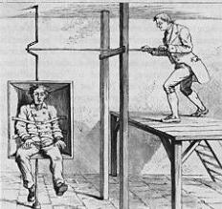
- understanding of mental illness was very limited
  - treatments were _____________________________
__________________________________________
__________________________________________
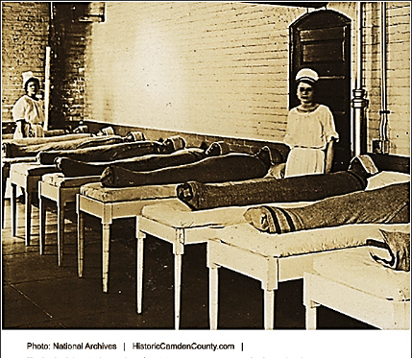
  - the mentally ill were tortured, exorcised, kept in prison
and or killed
- One treatment in the 1800s and early 1900s included
wrapping patients in wet sheets, then laying them out
bundled.

Contemporary Psychology
- As the field of Psychology emerged and
we gained understanding about
human behaviour and mental illness, treatment of the mentally ill changed.
- Today treatments tend to involve a
____________________ of individual
or group _______________________ (therapy) and possibly _______ treatment.
- The type of treatment used is often dependent on the type of disorder and the possible causes of that specific disorder.
  - For example, if the ___________________________________ than the treatment is often chemical or drug related.
Antipsychotic medications
Antidepressant medications

Psychoanalysis
- Psychoanalysis was the first formal __________________________ used. It was introduced by Sigmund Freud in the late 1800s.
- Freud believed that disorders were _______________________________ that stayed with the client as unresolved, unconscious conflicts (possibly of a sexual or violent nature). The unresolved conflict causes abnormal behaviours.
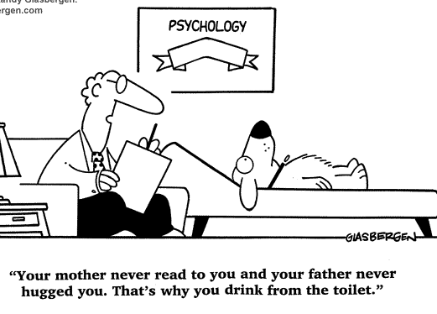
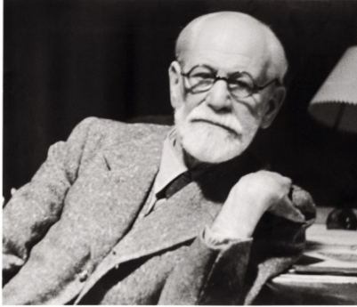
- The goals of psychoanalysis are to ____________________________________ so that the client can resolve the struggle and move on with their life.

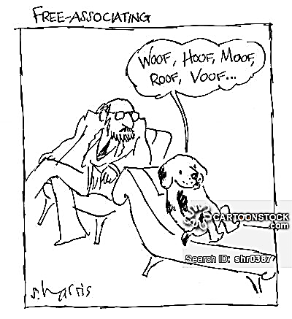
Psychoanalytic Methods
- Free Association
  - The client is encouraged to talk about anything and everything and the analyst looks for patterns and underlying information that might give clues to the conflicts.
  - Streams of consciousness – _____________
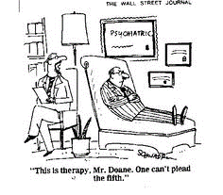
_________________ are used to see what is really on the person’s mind.
- Resistance
- Look at what the client ________________
about or talking about. If the client
__________________________________. These are looked at more closely.

- Dream Analysis
  - Dreams are analysed to see if they are ____________________ representations of conflicts or concerns.
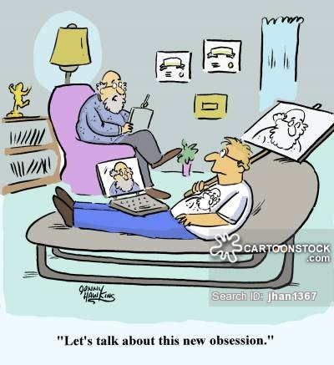
  - Dreams can convey ___________________
and repressed thoughts, memories and emotions.
- Transference
  - Clients at some point in therapy begin to ____________________________________
____________________________________
___________________________ with to their _____________________________________.
These need to be acknowledged and explored.
Cognitive Therapies
- Assumes that maladaptive behaviours are the result of ____________________ ______________and beliefs or ________________________.
- The goal of these therapies are to ______________________ _______________________ and thus change the maladaptive behaviour.
- Rational Emotive Therapy
- RET is confrontational therapy that _________________ the client’s irrational beliefs.
  - If the client’s belief is irrational the resulting consequence can also be distressing or negative.
  - Change the belief, change the outcome to something more manageable and realistic.
- Overcoming Negative Thinking
- Clients encouraged to recognize ____________________ ‘automatic thinking’ and replace that type of thinking with more helpful thoughts.

Biological Therapies
- This perspective views the client as a patient who has a biologically based illness that needs to be treated.
- The goals of biological therapies are to eliminate or control biological cause of behaviour and restore balance of neurotransmitters.
Drug Therapy
- _________________ drugs or major tranquillizers are used to treat schizophrenia, psychotic and personality disorders.
- _________________ drugs are used to treat anxiety disorders and mood disorders.
- _________________ is often used for bipolar disorder (a mood disorder)
- Drawbacks include – side effects, slow acting, relapse if you stop using
ECT
- Electric shock is sometimes used to treat severe depression.
  - One or two electrodes are place on the client’s head and a mild
electric current is passed through the brain.
Patients lose consciousness for 30-6- seconds and seizure which is necessary for the effect to occur.
  - temporary help by ________________________________ in the brain
Psychosurgery
- _________________ – frontal lobes of brain are severed (used in past 10s of thousands from 1935-1955) negative side effects deterred use.
- __________________ - electrodes are used to destroy small bundle of nerves connecting to the emotions centres of the brain has helped some clients with obsessive compulsive disorder.
Behavioural Therapies
- Associated to learning theory that says _________________________________ or _____________________________________________________________
______________________________________________. Includes learning from classical conditioning, operant conditioning or observational learning.

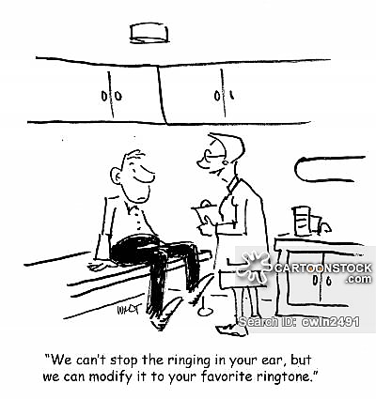
  - The goals of this type of therapy are to replace negative behaviours with more desired behaviours.
Behaviour Modification
- Based on operant conditioning, the client is ______________ for positive desired behaviours. Negative behaviours are ignored.
- Some use _______________ like stars or play money that can be cashed in for other rewards.
- Some use ___________________to eliminate negative
behaviours. This is a negative punishment (something is taken away).
- Some use _________________________ is giving people too much of what they want to the point of it losing its attraction.
Observational Learning (Modelling)
- Clients watch other people behaving in a certain way (that they fear) while the model
is experiencing positive outcomes.
Classical Conditioning
- _______________________ is used to teach the client new responses to stimulus that has produced negative responses. This is often used for phobias or to overcome fears. The client is slowly introduced to more and more threatening stimulus till they
are able to deal with the stimulus that they are afraid of.
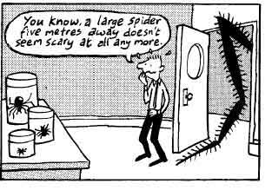
- ___________________ is used by exposing the client to a feared object in large doses till their fear subsides.
- ___________________ is used to discourage a negative behaviour. The client is exposed to the harmful behaviour and given negative painful stimulus at the same time. They are conditioned to dislike the negative activity.

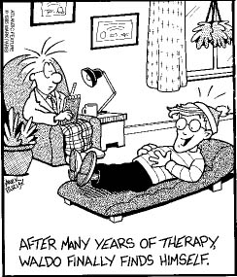
Humanistic Therapies
- Humanistic therapies are based on a more _______________________________ nature and __________________________. Individuals are viewed as unique and self-determining with the ability and freedom to lead rational lives and make rational choices. Humanistic therapists encourage personal growth and teach clients how to ________________ _____________________and take responsibility for their behaviour and for what they become in life.
Person centred therapy
- This type of therapy is based on Carl Rogers’s beliefs that humans are innately good and if allowed to develop naturally, will grow toward __________________ ____________________ (reaching their potential). Some don’t make it to self-actualization because they block their own progress when they act in ways that are inconsistent with their true self in order to gain the positive regard of others. The focus of the therapy therefore is on conscious thoughts and feelings. The therapist attempts to create a _________________________________ where they can be free to be themselves. _____________________________.
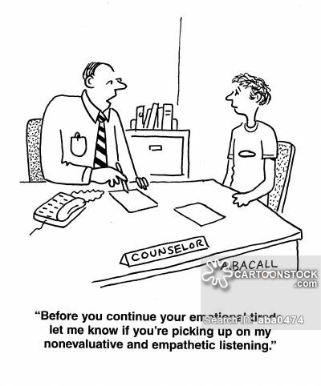
- The therapist must have unconditional positive regard for the client. This means they accept the client for who they are regardless of their behaviour, attitudes and feelings.
- The therapist’s feelings must be genuine, not just a professional front.
- The therapist must show _____________ to the client (understanding of the person’s situation, feelings or emotions).
“Before you continue your emotional tirade, let me know if you are picking upon my non-evaluative and empathetic listening.”
- The therapist practices _____________________ and reflects client’s thoughts back to them so that they can see themselves more clearly and in a more positive light.

