Socialization & Anthropology
so·cial·i·za·tion
______________________________________________________________________________________________________________________________________________________________________________________________________________________________________________________________________________________________________________________________________________________________________________________________________________________________________________________________________________________________________________________________________________________________________________________________________________________________________________________

Human infants are born _____________________. They must be transformed by their parents, teachers, and others into cultural and socially proficient beings. The general process of acquiring culture happens during the process of socialization.

During socialization, we learn the ___________________ of the culture we are born into as well as the __________ we are to play in life. For instance, girls learn how to be “girls” or a range of gendered behaviours, daughters, sisters, friends, potentially wives, significant others and possibly mothers. In addition, they learn about the occupational roles that are possibilities. We also learn and usually adopt our culture's norms through the socialization process.

Norms are the conceptions of ______________________________________________ that are held by most members of the society. While socialization refers to the general process of acquiring culture, anthropologists use the term enculturation for the process of ___________________________________________. You were enculturated to your specific culture by your parents and the other people who raised you.

Socialization is important in the process of ____________________________. While much of human personality is the result of our genes, it can also be attributed to socialization. The ________________________________________________________________________ __________________or the way we see the world, others and our own situation.
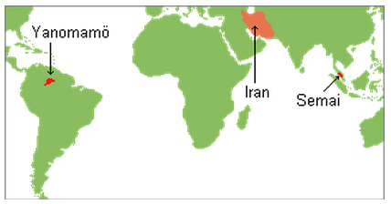
This is why there are so many differences between the common personality types in _______________________________. _________________For instance, the Semai tribesmen of the central Malay Peninsula of Malaysia typically are _________ people who do not like violent, aggressive individuals. In fact, they avoid them whenever possible. In contrast, the Yanomamö Indians on the border area between Venezuela and Brazil usually train their boys to be tough and ________________. The ideal Yanomamö man does not shrink from violence and strong emotions. In fact, he seeks them out. Likewise, Shiite Muslim men of Iran are expected at times to publicly _______________________________ through the emotionally powerful act of self-inflicted pain.
Hint… remember the characteristics of culture… Behaviours, Knowledge and Beliefs,
and Material Culture - Try to include two or three examples from each area

Canadian Cultural Characteristics & Socialization
Flip over
Get a partner and list as many Canadian characteristics as you can | What social interactions, formal and informal communications and experiences have you had to provide this sort of socialization as a young Canadian?

