Sleep and Dreams
Minds On
- How much sleep did you get last night? __________
- How much the night before ? _____________
- What do you think is average for you? _________
Average Hours of Sleep
Needed
- Adults seem to need an average of ___________ hours sleep.
- New borns and teens are experiencing high growth periods and need more sleep.
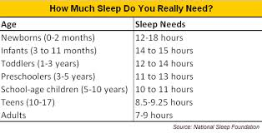
Teens need between ______________ hours.

What’s up with sleep?
- Sleep uses approximately __________ of our life, when we don’t get our sleep it has a negative impact.
- Sleep ______________________ used while we are awake, we __________ while we sleep, we __________ damage.
- Lack of sleep causes fatigue, less immunity to disease, hand tremors, irritability and inattention.

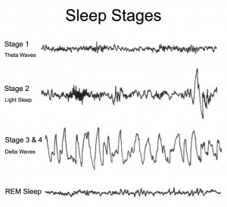
What stages do we go
through while we sleep?

What is REM Sleep?
- It is an active period of sleep marked in humans by intense _______________________ and rapid bursts of _______________________.
- REM > Rapid Eye Movement > people can see when you __________________________ > eyes move back and forth under lids.
- REM occurs during ______________________________.
- When researchers woke people during this phase they could _____________________ their dreams.
How do scientists know that REM sleep is important?
- they did an __________________.
- they prevented people from experiencing this stage by waking them up regularly.
- the findings?
  - the subjects became short-tempered and less able to concentrate.
  - Other effects include depression, weight gain, immune system suppression and slower reaction times.
- Electrodes attached to the scalp can record brainwaves, which helps us to know there are 4 stages of sleep we cycle through about every 90 minutes over and over again all night long.

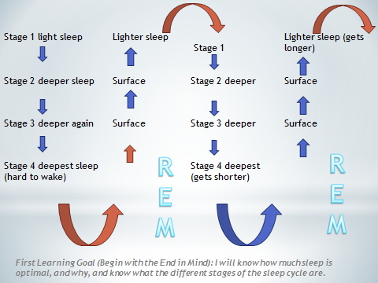
We sleep in stages
In stage 2 a more stable sleep occurs. Chemicals produced in the brain, block the senses making it difficult to
be woken.
Stage 3 is a deep sleep. A growth hormone is released during this stage. Most of stage three sleep occurs
in the first third of the night.
Stage 4 is the REM sleep. REM sleep revitalizes the memory. In this stage; brain activity is very high and
intense dreaming is likely to occur.

In stage 1 we experience a light transitional sleep. This is where is where drowsiness and sleep begins.

Dreams
- While we don’t all experience the varied states of consciousness, we do _____________ and we __________________.
- According to researchers our dreams vary in ______________depending on how long that particular REM cycle is.
- Most dreams are fairly ______________.
- Some tend to be negative, it is common to dream about failure or being attacked or losing out.
How do cognitive psychologists explain
the value of dreams?
- Cognitive psychologists feel that dreams help us ________________________________ ______________and emotions, and sort things out (we tend to sleep more after stressful days).
  - This makes sense if you think that many dreams are fairly ordinary.
How do psycholanalysts (Freud) explain the
function of dreams?
- Psychoanalysts believe dreams have _________________________ that are key to understand our drives, fears and so on.
- Freud attributed the libidinal drive (life force) as the primary creator of dreams that a person’s wishes for.
- Freud also felt that tapping into a person’s ________________________would allow a therapist to help a person ___________________________ that may be bothering them, that they may not be aware of.
eg. Who is the spider?

