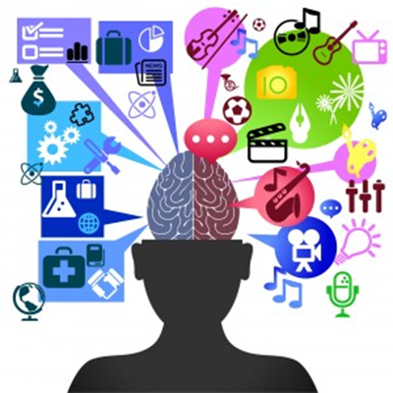
Psychology 101
The Early History
Psychology is the study of …
- _____________________________, or the way our brains work
  - _______________________
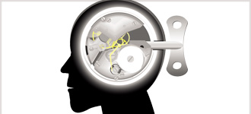
  - ________________________________
- _____________________ development
- human ________________________
- _________________________ these behaviours
Minds On…
How could you study our brains, behaviours and personalities if you did not know anything about that?
What about before the technology of today?
____________________________________________________________________________________________________________________________________________________________________________________________________________________________________________________________________________________________________________________________________________________
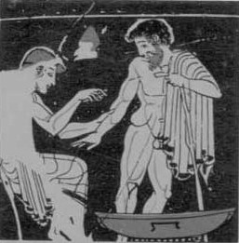
The Early Greeks
- Early Greeks hypothesized about human personalities by looking at _____________________ _____________________________________________.
- each humour was thought to give off ___________________________________ causing a person’s characteristics or temperament.
- the amounts of fluids … combinations and excess were thought to affect a person’s _________________________________________________________.
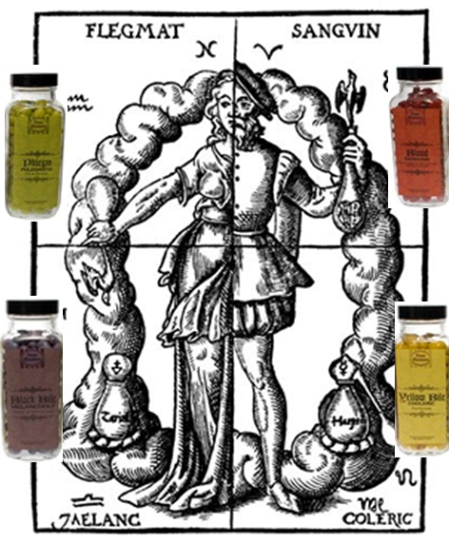
- __________________
  - An excess of phlegm could be found in people who are characteristically sluggish, dull, and passive

- __________________
  - An excess of blood could be found in people who are happy, generous, and passionate

- __________________
  - An excess of black bile could be found in people who are sad, gloomy, and lazy

- __________________
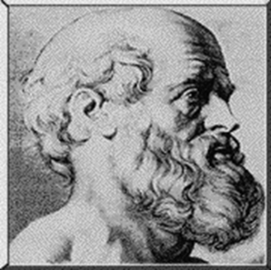
  - An excess of bile could be found in people who are violent, vengeful and fiery

Hippocrates(460 – 377 BCE)
- The father of modern medicine ___________________
_______________________________________________
  - made note that people who were suffering from some form of accidental brain injury often underwent a ___________________ __________________________.
  - he concluded that brains are the centre of _______________ (joy, sorrow and so on)
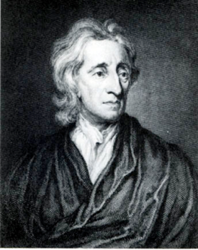
John Locke (1643 – 1704)
- proposed that the human mind received information through _________________________(what we see, smell, hear & so on)
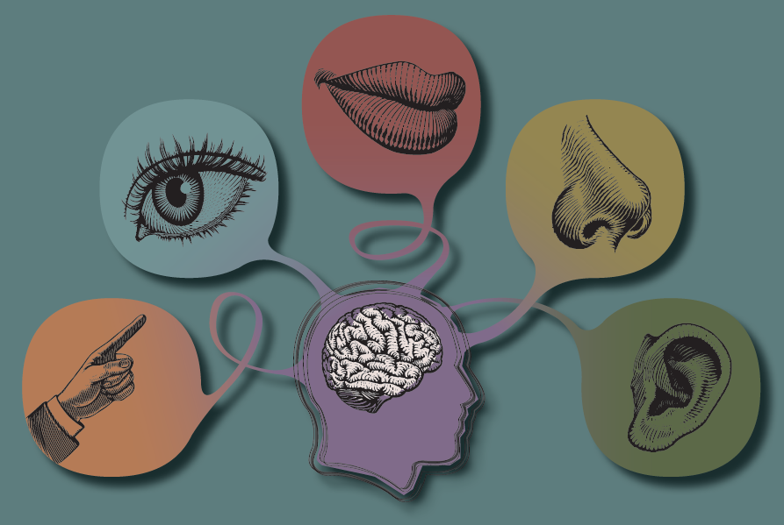
Modern day Psychology
- Psychology really began in the late _________________ (1800s) when we began to take a more _______________________ to the study of human behaviour.
- Scientific research and ______________________________ began to be set up for the purposes of understanding the human mind and behaviour
- ____________________________________ was adopted.

