Motivation & Human Behaviour
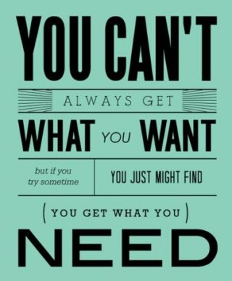
Motivation is the study of why we do the things we do or the
causes of our behavior
Minds on…
- What does this mean?
______________________________________________________________________________________________________________________________________________________________________________________________________________________________________________________________________________________________________________________________________________
- What implications does it have for helping us to
understand what roles wants or needs play when it
comes to motivating human behaviour?
________________________________________________________________________________________________________________________________________________________________________________________________________________________________________________________________________________________________________________________________________________________________________________________
- What about feelings and emotions? How are they connected to wants and needs? Therefore, how do they affect human behavior?
__________________________________________________________________________________________________________________________________________________________________________________________________________________________________________________________________________________________
What about habits, impulses & intuition?
_______________________________________________________________________________________________________________________________________________________________________________________________________________________________________________________________________________________
_____________________________________________________________________________________________

So…
Are we driven by our biological needs or our social needs? Example?
________________________________________________________________________________________________________________________________________________________________________________________________________
Do you think it is a bit of both? If so, why?
________________________________________________________________________________________________________________________________________________________________________________________________________

Biological Motivation | Social Motivation
inborn or innate needs such as  hunger | ________________________________ needs
these needs are ____________________ | need for social approval such  as praise & rewards encourages learned behaviours that are desired
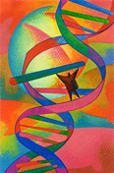  they are derived by ___________________ or genetics possibly through genetic pre-programming or predisposition such as personality | these behaviours are driven  by _________________________ or our social environment
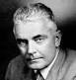
Nature versus Nurture?

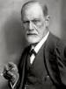
Nature Nurture
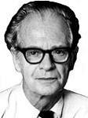
Freud, we are driven by Watson, & Skinner, we are
our life and death _____________ driven by a desire for ___________________
- sexual drive - praise from others
- aggression

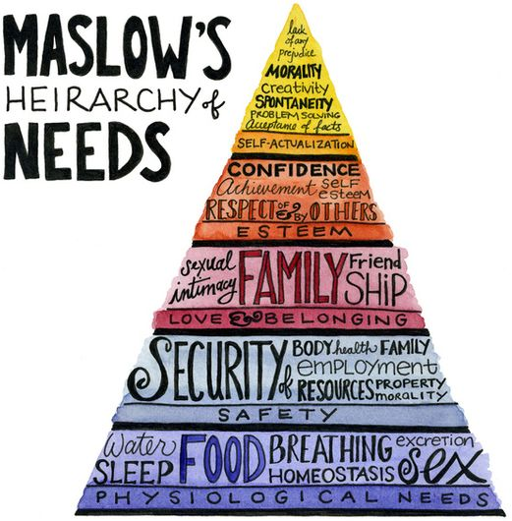

Both
Maslow, we are driven by ___________________
_________________________________________initially,
but once they are met we are also driven by
____________________________
- food, water, shelter
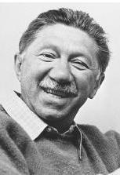
- security
- love and acceptance
- _____________________________________
- self-actualization

