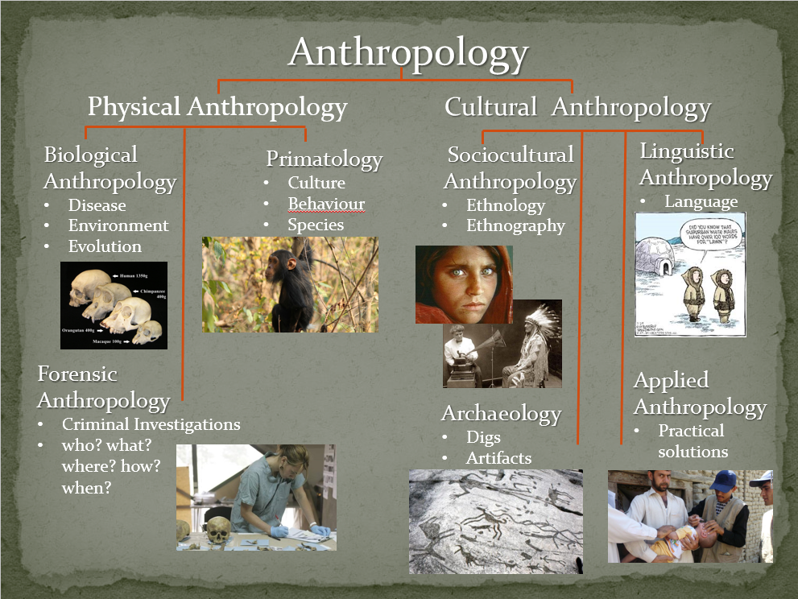
Anthropology 101 [fill in the blanks from the first slide]

Social or Cultural Anthropology
- Investigates the ____________, ________________ and _____________________ of human cultures
- Culture is a way of living learned over time and ___________________________ of people
  - including knowledge, language, beliefs, art, morals, laws, and customs
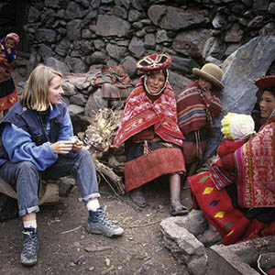
Explain how each of the four main branches can be represented here.
Review Activity
- There are four main branches …
  - Archaeology
  - Applied Anthropology
  - Linguistics
  - Ethnology & Ethnography

Come back to the Review Activity after
we have gone through all four.
Review Activity explain how the branches can be represented in the photo
Archaeology ____________________________________________________________________________________________________________________________________________________
Applied Anthropology
____________________________________________________________________________________________________________________________________________________
Linguistics
____________________________________________________________________________________________________________________________________________________
Ethnology & Ethnography
____________________________________________________________________________________________________________________________________________________
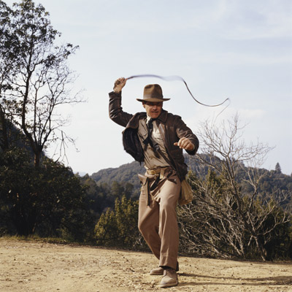
Archaeology
- examines the __________ through archaeological digs to unearth information that is buried and forgotten.
- Bits and pieces help researchers put together ideas about how individuals, families and cultures lived together.
Applied Anthropology
- uses research results to __________________________________
for people in different cultures.
- it could be solutions from one culture shared to another.
  - Example would be researchers sharing irrigation methods with a developing country.
- or it could be solutions from research done in one culture and then solutions applied to the problem.
- Example would be researchers looking at a study of changing marriage patterns in Swaziland which then leads to policy recommendations for a program in population control.
What type of concerns might arise when practising this type of anthropology?
____________________________________________________________________________________________________________________________________________________________________________________________________________________
Linguistics
- studies ______________________ over time.
- look at how languages are related and their meanings.
- often use primary research such as case studies, interviews, content analysis and participant observation to better understand the _________ language in a particular culture.
Ethnology & Ethnography
Ethnology
- the study of & _______________ of past cultures and or contemporary cultures.
- primary research involves looking at case studies, analyzing data, observations and interviews.
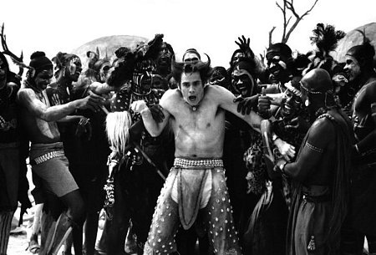
Ethnography
- in-depth description of a particular culture
- _____________ research is done through ___________________________ where the anthropologist ______________ the culture for a period of time conducting observations and in depth interviews with individuals or groups.
Which is the most interesting & Why?
____________________________________________________________________________________________________________________________________________________________________________________________________________________________________________________________________________________
Which is the most challenging & Why?
____________________________________________________________________________________________________________________________________________________________________________________________________________________________________________________________________________________
Which is the most important & Why?
_______________________________________________________________________________________________________________________________________________________________________________________________________________
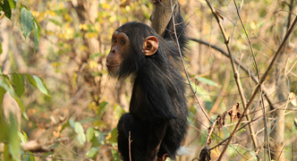
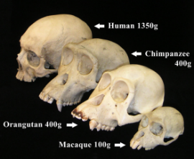
Physical Anthropology
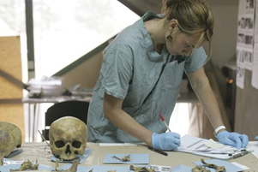
- Studies human __________, human biology
and other _________________
- Have extensive training in human skeletal anatomy
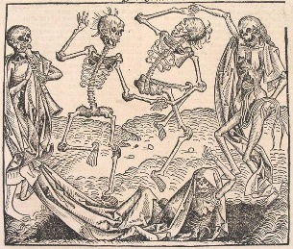
- Some subfields overlap but each has its own specialists
and methods of investigation
Biological Anthropologists
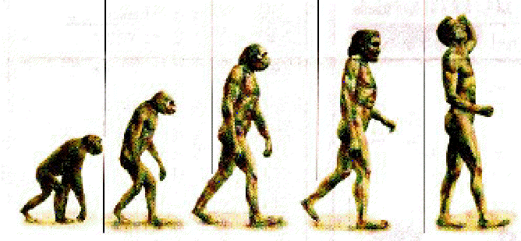
- Study _________________ and illness
- Study environmental and social conditions
- Study human ________________
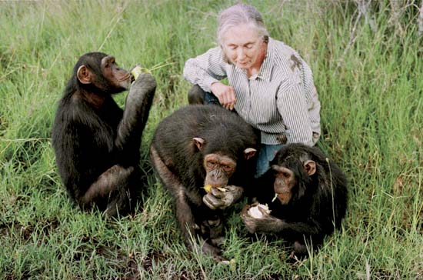
Primatologists
- Study primates to better understand their
____________________ and species as a whole
- ____________________ primates to humans
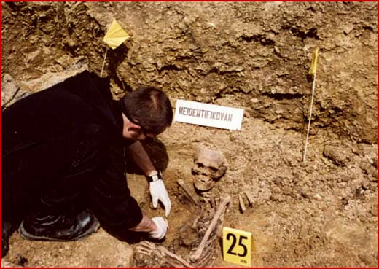
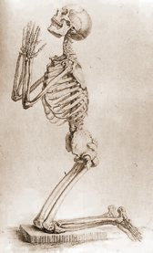
Forensic Anthropologists
- the examination of human skeletal ____________________ for law enforcement to determine the identity of unidentified bones.
- a forensic anthropologist can aid law enforcement in developing a profile on unidentified remains.
  - profiles include sex, age, ethnicity, height, length of time since death, and sometimes the evaluation of trauma seen on bones.

Which is the most interesting & Why?
_______________________________________________________________________________________________________________________________________________________________________________________________________________
Which is the most challenging & Why?
_______________________________________________________________________________________________________________________________________________________________________________________________________________
Which is the most important & Why?



