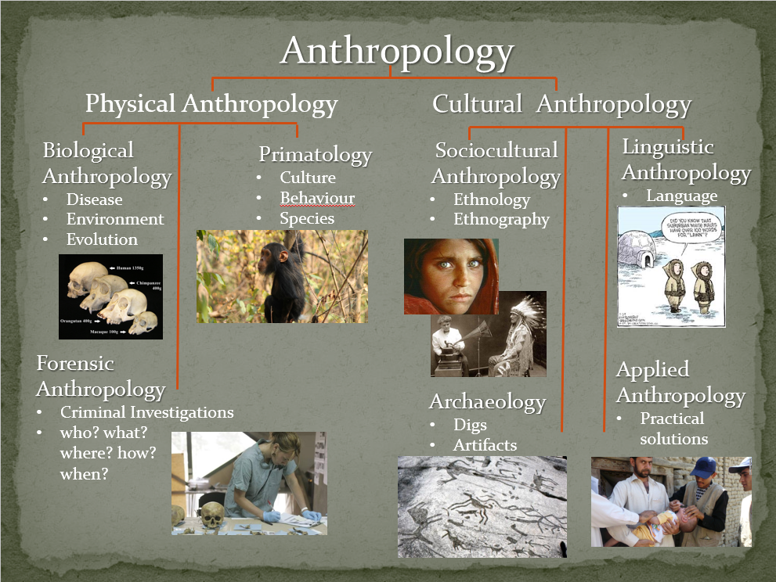
Anthropology 101 [fill in the blanks from the first slide]

Social or Cultural Anthropology
- Investigates the _origin _, _development _ and __functioning_____ of human cultures
- Culture is a way of living learned over time and _shared by a group______ of people
  - including knowledge, language, beliefs, art, morals, laws, and customs

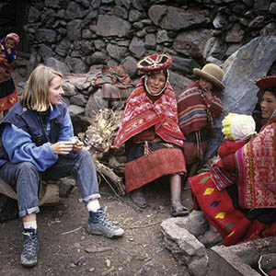
- There are four main branches …
Explain how each of the four main branches can be represented here.
Review Activity
  - Archaeology
  - Applied Anthropology
  - Linguistics
  - Ethnology & Ethnography
Come back to the Review Activity after
we have gone through all four.
Review Activity explain how the branches can be represented in the photo
Archaeology __women may be there as part of a dig, or she may have artifacts and is asking the people who belong to the culture she is studying what these artifacts may be
Applied Anthropology
__woman may be asking for more information about a project that she wants to implement to assist this group perhaps something to do with child care, or she may be getting tips that she can bring back to her own culture?
Linguistics
__may be learning the language and trying to support the survival of language
Ethnology & Ethnography
__woman may be comparing the cultural practises from this group with a neighbouring culture, or her own; and she may be living with this group to get a very detailed picture of their culture
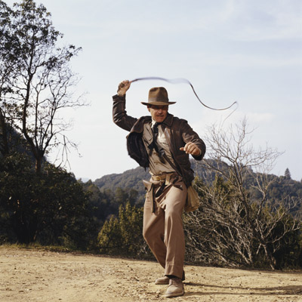
Archaeology
- examines the _past__ through archaeological digs to unearth information that is buried and forgotten.
- Bits and pieces help researchers put together ideas about how individuals, families and cultures lived together.
Applied Anthropology
- uses research results to _solve practical problems_ for people in different cultures.
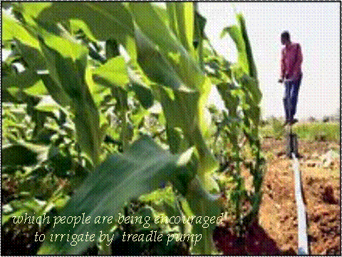
- it could be solutions from one culture shared to another.
  - Example would be researchers sharing irrigation methods with a developing country.
- or it could be solutions from research done in one culture and then solutions applied to the problem.
- Example would be researchers looking at a study of changing marriage patterns in Swaziland which then leads to policy recommendations for a program in population control.
What type of concerns might arise when practising this type of anthropology?
Pitfalls include – being ethnocectric and assuming what needs a culture has in terms of giving support, can be insulting to the culture, can be misguided, can be harmful – due to misunderstanding the situation and the importance of whatever system has been changed or “fixed”, frustration, clash of ideologies and beliefs example clitorectomies, Ethiopian women, poverty & Oscar Lewis
Linguistics
- studies __language changes__ over time.
- look at how languages are related and their meanings.
- often use primary research such as case studies, interviews, content analysis and participant observation to better understand the _use of_ language in a particular culture.
Ethnology & Ethnography
Ethnology
- the study of & _comparison___ of past cultures and or contemporary cultures.
- primary research involves looking at case studies, analyzing data, observations and interviews.
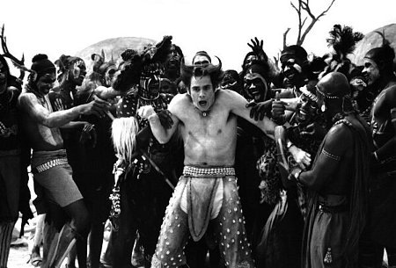
Ethnography
- in-depth description of a particular culture
- Primary research is done through _participant observation_ where the anthropologist _lives among_ the culture for a period of time conducting observations and in depth interviews with individuals or groups.
Which is the most interesting & Why?
____________________________________________________________________________________________________________________________________________________________________________________________________________________________________________________________________________________
Which is the most challenging & Why?
____________________________________________________________________________________________________________________________________________________________________________________________________________________________________________________________________________________
Which is the most important & Why?
_______________________________________________________________________________________________________________________________________________________________________________________________________________
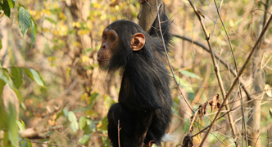
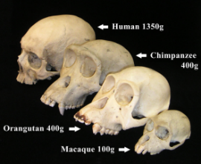
Physical Anthropology
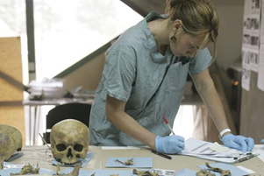
- Studies human _evolution_, human biology
and other __primates__
- Have extensive training in human skeletal anatomy
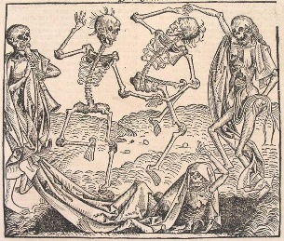
- Some subfields overlap but each has its own specialists
and methods of investigation
Biological Anthropologists
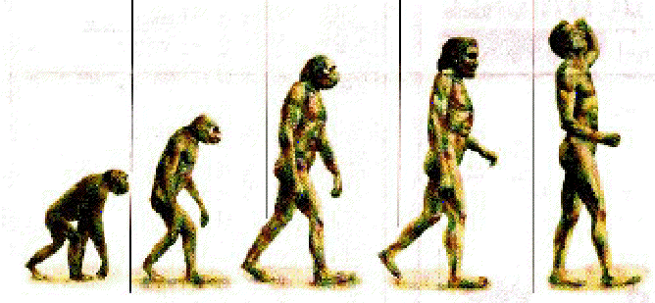
- Study _diseases__ and illness
- Study environmental and social conditions
- Study human __evolution__
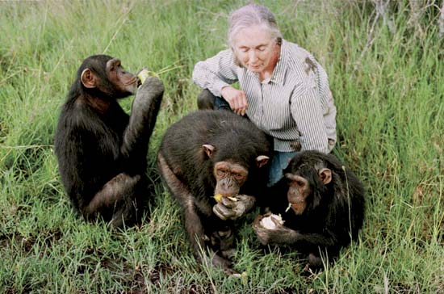
Primatologists
- Study primates to better understand their
_culture and behaviours_ and species as a whole
- __Compare__ primates to humans
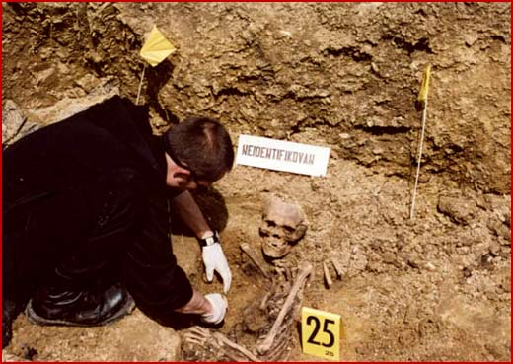
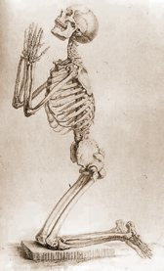
Forensic Anthropologists
- the examination of human skeletal __remains__ for law enforcement to determine the identity of unidentified bones.
- a forensic anthropologist can aid law enforcement in developing a profile on unidentified remains.
  - profiles include sex, age, ethnicity, height, length of time since death, and sometimes the evaluation of trauma seen on bones.

Which is the most interesting & Why?
_______________________________________________________________________________________________________________________________________________________________________________________________________________
Which is the most challenging & Why?
_______________________________________________________________________________________________________________________________________________________________________________________________________________
Which is the most important & Why?
_______________________________________________________________________________________________________________________________________________________________________________________________________________
