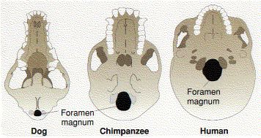
The opening in the skull where the spinal cord enters is called the foramen magnum. It is at the rear of the skull of quadrupedal mammals like the dog, shifted forward in knuckle-walking hominines like the chimpanzee, and farther forward still in bipedal hominins like Lucy (Australopithecus afarensis) and modern humans.

