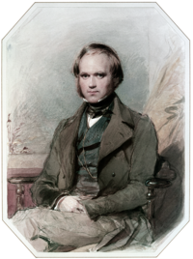
Charles Darwin &
the Theory of Natural Selection
In his book ____________________ Charles Darwin introduced the concept of natural selection.
natural selection…
is nature’s process which acts to _____________ (save) and keep any _____________________ a species may have.
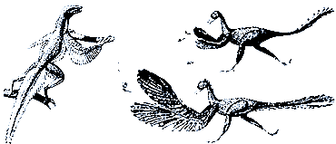
- suppose a member of a species were born with
an advantage.
- e.g. a _______________________________ would have an obvious advantage over other reptiles related to it.
- they would have a ____________________________ and therefore are more likely also to be around to reproduce, allowing for the trait to possibly continue on.
- natural selection would act to preserve this _______________________ that is helpful (wings).
- the species that have that trait will be __________________________________ and pass it on to their offspring and so on.
- so basically… natural selection is _________________________ equivalent of selective or domestic breeding.
- the difference between domestic breeding and natural selection is, nature itself is the ________________________________________ will be most helpful.
Domestic Animal Breeding
Over centuries, breeders have _______________________________________ in domestic animal populations by selecting specific dogs to breed. They have been able to ____________________________ (given the trait is already present in the genetic code) and suppress undesired traits over time.
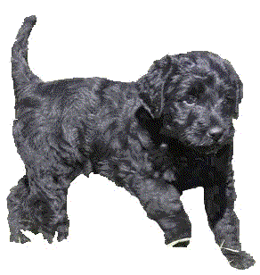
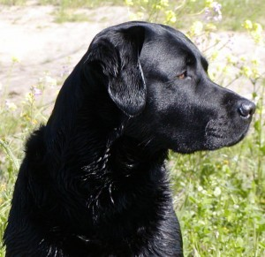
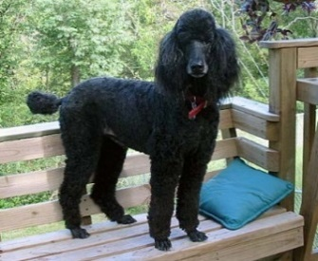
- E.g. _________________________make great guide dogs as they are very intelligent but they also shed a lot, which makes it hard for owners with allergies, when mixed with poodles (shorter hair breed), they produce a new dog breed, the _______________________. This mix of breeds is highly intelligent, given that both poodles and labs are ranked in the top 10 of all dogs.

- Survival of the fittest… natural selection essentially states that the strongest of a species survive.
the basic idea is that when ______________________________, those which are best suited to the new circumstances or environment will thrive. Those who are not ideally suited will not be able to compete.
Sexual selection also occurs, through _________ selection, so desired traits can be retained over others less desired.

Charles Darwin proposed this principle after observing some population variations in birds.
- He noticed that animals within a species often had ____________________________, and that those traits made some more suited to certain conditions.
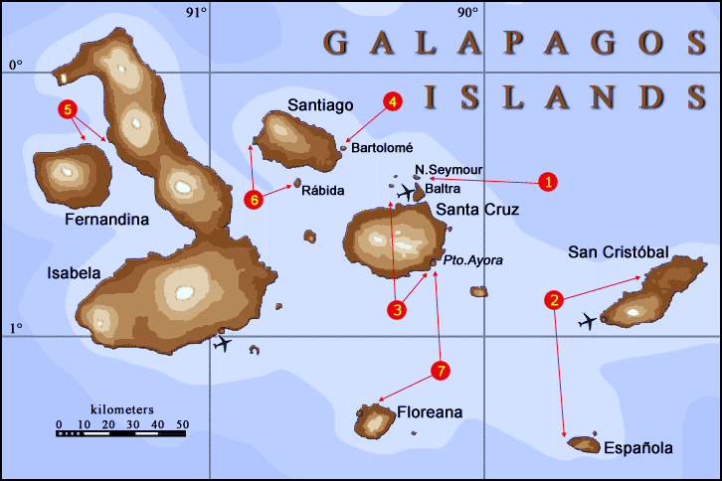
- Darwin's theory was that, over time, the better suited animals would thrive and the others _____________________ completely. The resulting population would be entirely made up of those animals with the "better" trait.
Darwin visits the Galapagos Islands.
- the islands are _____________________ from each other and have different environmental factors.
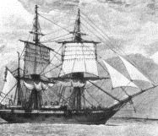
- Darwin observed that some varieties of animals or birds lived on some islands and not others.
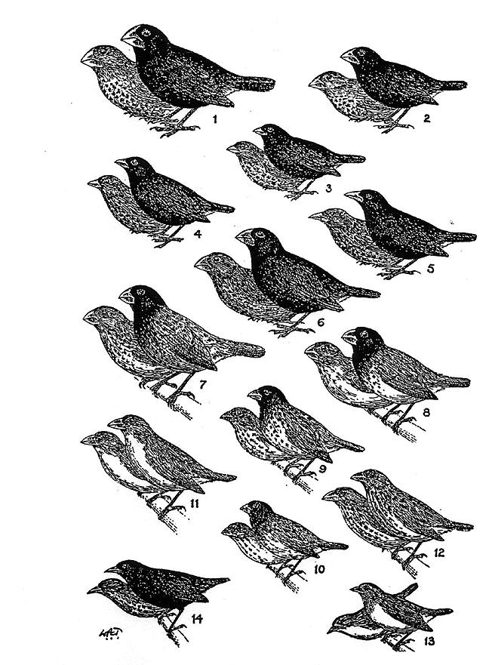
- He began to collect and record data on the different species that he found in the islands.
- Variations within a single species make some members better suited to handle different circumstances.
- e.g. the birds had differently shaped beaks which would allow them to eat from certain plants and trees more or less easily.
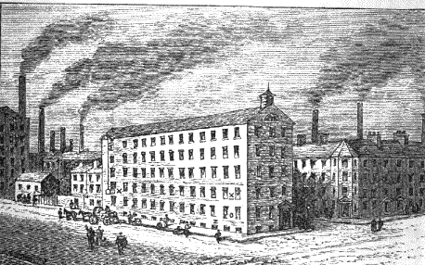
- The moths that lived in cities in England around the time of the industrial revolution had to deal
with increased pollution.
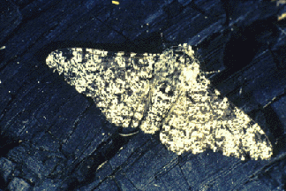
- Lighter-colored moths _________________ on soot-stained buildings and trees, and thus… were easier targets for birds.
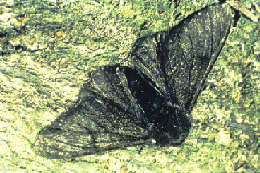
- The darker moths found it _____________________________, because they blended into the darkened environment. As a result, the population of light-colored moths lessened over time, and the darker-colored moths increased.
- The dominance of the __________________________ is used as an example of natural selection.

But…
how did the species actually pass on their traits to their offspring?
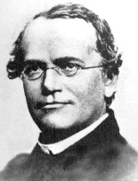
Darwin couldn’t explain this…
- enter Gregor Mendel

