Station 1 Humanism and Maslow’s Hierarchy of Needs
- Go to http://www.wisc-online.com/Objects/ViewObject.aspx?ID=I2P401
- Look at this diagram and the names of the 5 levels of needs.
- Together as a team, prepare to answer a series of questions that examine how well you understand the concept of the Hierarchy of Needs.
- When you are ready as a group, click Next and read the next prompts till you have read the example exercise. Then click on Next.
- Go through the six situations and see how many you can get correct.

Personally, I believe there is more than one correct answer and would be willing to challenge some of the responses on the game.

- Need being met _________________________ Need being neglected ________________________
- Need being met _________________________ Need being neglected ________________________
- Need being met _________________________ Need being neglected ________________________
- Need being met _________________________ Need being neglected ________________________
- Need being met _________________________ Need being neglected ________________________
- Need being met _________________________ Need being neglected ________________________

Consolidate

Which ones do you think could be argued more than one way?
________________________________________________________________________________________________________________________________________________________________________________________________________________________________________________________________________
Which do you think is /are the most important need/s to have met for humans to thrive – be well?
________________________________________________________________________________________________________________________________________________________________________________

Station 2 Classical Conditioning & Pavlov’s Dog Game
- Review the principles of classical conditioning as follows…
Take any stimulus and see if there is a reaction example – ring a bell and see if anyone does anything.
Take another stimulus that there is often a reaction or response to – examples
food > drooling
being hit > flinching or saying ouch
burning fingers> pull hand away
Continuously pair the stimulus that has no reaction with the stimulus that provokes a reaction until the stimulus with no reaction now has a reaction. This is considered learning. A being learns to have a new response or reaction when given the stimulus after repeated pairings.
- Go to http://www.nobelprize.org/educational/medicine/pavlov/pavlov.html
- Click on the center of the picture to start the game.
- Play one of the instruments below the sleeping dog and at the same time or very quickly after drag one type of food to the dog’s bowl.
- Repeat this same action over and over until the dog now responds to the instrument without needing the food. You will know you are successful if the diploma shows up.
- Now go back to the beginning and see if you can mess it up or change it

Consolidate…
Summarize how you win the game. Which instrument and food did you pair? How would a person mess it up?
________________________________________________________________________________________________________________________________________________________________________________________________________________________________________________________________________________________________________________________________________________________________________________________________________________________________________________________________________________________________________________________________________________________________________________________________________________________________________________________________________________________________________________________________

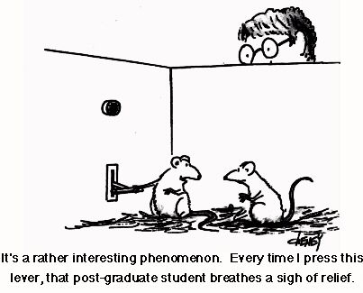
Station 3 Operant Conditioning
- Review the principles of operant conditioning as follows…
ABCs
antecedent --- behaviour---- consequences
Operant conditioning is a method of learning that occurs through rewards and punishments for behaviour. Through operant conditioning, an association is made between a behaviour and a consequence for that behaviour.
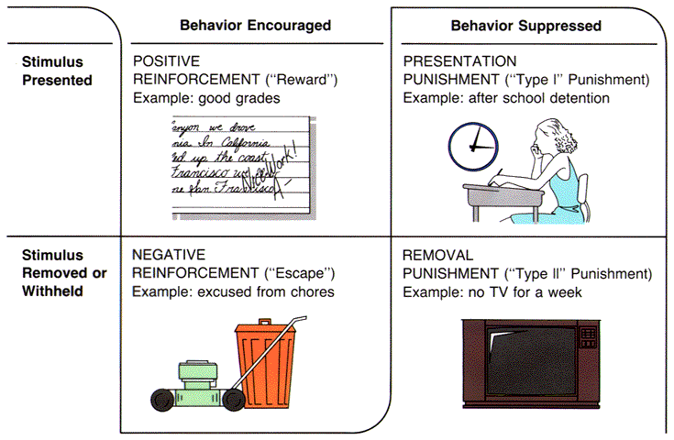
Positive and negative reinforcement results in increased behaviours, and positive and negative punishment result in decreased behaviours.
Examples of positive reinforcement for behaviours include… cookies, quickies, gold stars, praise, money (giving)
Negative reinforcements for behaviours are things that take away noxious or unpleasant situations and make them better for people, removing something problematic (taking away)
Examples of negative reinforcement include… pain pills, air conditioners, taking away a test or exam for good behaviour, shortening a grounding, removing a stressor
Examples of positive punishment to decrease undesired behaviour include… physical punishment like being spanked or hit (giving)
Examples of negative punishment to decrease undesired behaviour include… losing the car, losing privileges like social media or television (taking away)
There are also primary and secondary reinforcements; primary reinforcements do not require conditioning or learning to be reinforcement, secondary reinforcements are those that we learn about, like if I walk on the sidewalk instead of in the puddle I don’t get wet shoes
In order for conditioning to have occurred, desired behaviour needs to have increased. In order for punishment to have occurred, undesired behaviours need to decrease.
- Go to https://www.youtube.com/watch?v=PQtDTdDr8vs to watch an example of a rat pressing a lever and being reinforced by a food pellet. The process repeats itself as the rat continues to repeat the lever pressing behaviour and being rewarded with a food pellet.
- Go to http://www.funtrivia.com/playquiz/quiz258742f9578.html
- As a group complete the quiz. Talk amongst yourselves before you answer each question. When you have either a consensus or a majority select the answer you think is the most correct. If you have nothing, guess.
- What was the group score out of 15? __________
- Repeat the quiz to make sure you can get perfect.

Station 4 Psychoanalysis
Go to https://www.youtube.com/watch?v=7vFf5CS27-Y and watch the mini lesson on Freud and Psychoanalytic theory
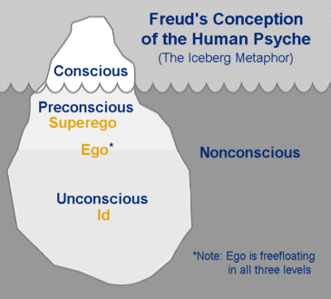
Freud believed in the unconscious, preconscious and conscious aspects of awareness. Each motivate behaviour, but we are only fully aware of the conscious, partially aware of the preconscious (can be recalled if needed) and not easily aware of the unconscious.

Of these, there are also three parts of any person’s personality.

Review the elements of personality as follows…

An Intro to the Psychoanalytic Model of Personality
In this theory, Sigmund Freud explains that each person’s personality is formed of three parts: the Ego, the Superego and the Id. Psychoanalysis is the process of using what we know about these three parts of someone’s personality to analyze the ways that person behaves. In this activity, you will use Freud’s theory to analyze the characters in The Cat In The Hat by Dr. Seuss. To help prepare you for this activity, read the following explanations for id, ego, and superego.

Id
The id is the part of the personality that contains our primitive impulses—such as thirst, anger, hunger—and the desire for instant gratification or release. According to Freud, we are born with our id. The id is an important part of our personality because as newborns, it allows us to get our basic needs met. Freud believed that the id is based on our pleasure principle. The id wants whatever feels good at the time, with no consideration for the other circumstances of the situation. The id is sometimes represented by a devil sitting on someone’s shoulder. As this devil sits there, he tells the ego to base behavior on how the action will influence the self, specifically how it will bring the self-pleasure.

Superego
The superego is the part of the personality that represents the conscience, the moral part of us. The superego develops due to the moral and ethical restraints placed on us by our caregivers. It dictates our belief of right and wrong. The superego is sometimes represented by an angel sitting on someone’s shoulder, telling the ego to base behaviour on how the action will influence society.

Continued on next page

Ego
The ego is the part of the personality that maintains a balance between our impulses (our id) and our conscience (our superego). The ego is based on the reality principle. The ego understands that other people have needs and desires and that sometimes being impulsive or selfish can hurt us in the end. It is the ego’s job to meet the needs of the id, while taking into consideration the reality of the situation. The ego works, in other words, to balance the id and superego. The person or self is represented by the ego, with a devil (the id) on one shoulder and an angel (the superego) on the other.
Psychoanalysis of Characters in The Cat In The Hat
Go to https://www.youtube.com/watch?v=HQW8AfBdea4 and watch the story book The Cat in the Hat

Together as a group, decide which character was which element of the personality: id, ego or superego. Circle the part of the psychological self that best describes the character’s actions in each area of the story (beginning, middle, and end).

Write an argument in the last column that explains the overall psychological personality of the character, based on your observations.

 | Beginning | Middle | End | Conclusion
The  Narrator  and Sally | id  ego  superego | id  ego  superego | id  ego  superego
The Cat | id  ego  superego | id  ego  superego | id  ego  superego
The Fish | id  ego  superego | id  ego  superego | id  ego  superego
The Mother | id  ego  superego | id  ego  superego | id  ego  superego

Do you think this is reflective of society? Are more people ruled by their ego and superego or their id? _____________________________________________________________________
Why do you think that is? _______________________________________________________
____________________________________________________________________________

Station 5 Modeling or Social Learning Theory

Go to https://www.youtube.com/watch?v=77ql1emlCn4 and watch a little of this video

Go to https://www.youtube.com/watch?v=TA6ktsN0jro and watch the video

Pause the video at 1:33 and write down the definition of Observational learning.

Observational Learning is

________________________________________________________________________________________________________________________________________________________________________________________________________________________________________________________________________

Observational Learning occurs in four stages or there are four factors involved.

Pause the video at 1:36 and write down the four stages of Social Learning

Paying attention

________________________________________________________________________________________________________________________________________________________________________________

Remembering

________________________________________________________________________________________________________________________________________________________________________________

Reproducing

________________________________________________________________________________________________________________________________________________________________________________

Being motivated

________________________________________________________________________________________________________________________________________________________________________________

Consolidate
Think about violent video games and explain how each of these four factors could be relevant to learning violence through playing violent video games.
________________________________________________________________________________________________________________________________________________________________________________________________________________________________________________________________________________________________________________________________________________________________________________________________________________________________________________________
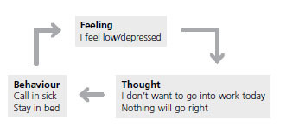
Station 6 Cognitive Theory
Cognitive behaviour therapy (CBT) is a type of psychotherapeutic treatment that helps patients understand the thoughts and feelings that influence behaviours. CBT is commonly used to treat a wide range of disorders including phobias, addiction, depression and anxiety. CBT is generally short-term and focused on helping clients deal with a very specific problem. During the course of treatment, people learn how to identify and change destructive or disturbing thought patterns that have a negative influence on behaviour.
Cognitive behaviour therapy is well-suited for people looking for a short-term treatment option that does not necessarily involve medication. One of the greatest benefits of cognitive-behaviour therapy is that it helps clients develop coping skills that can be useful both now and in the future.
In most cases, CBT is a gradual process that helps a person take small steps towards a behaviour change. Someone suffering from social anxiety might start by simply imagining himself in an anxiety-provoking social situation. Next, the client might start practicing conversations with friends, family, and acquaintances. By progressively working toward a larger goal, the process seems less daunting and the goals easier to achieve.
- Go to https://www.youtube.com/watch?v=bUOaHsxe8OQ and watch this short video.
- Then go to https://iveronicawalsh.wordpress.com/2012/04/15/the-abc-of-cbt-the-starter-exercisehandout-to-catch-your-negative-thoughts/ and cursor down to the examples I have an important exam… then answer these questions…

Pre Therapy…
- What was the activating event in this example? __________________________________________________________________________________________________________________________________________________________________________________________
- B. What is the potential belief given in this example? __________________________________________________________________________________________________________________________________________________________________________________________
- What are they saying is a possible consequence based on this belief or way of thinking?
__________________________________________________________________________________________________________________________________________________________________________________________
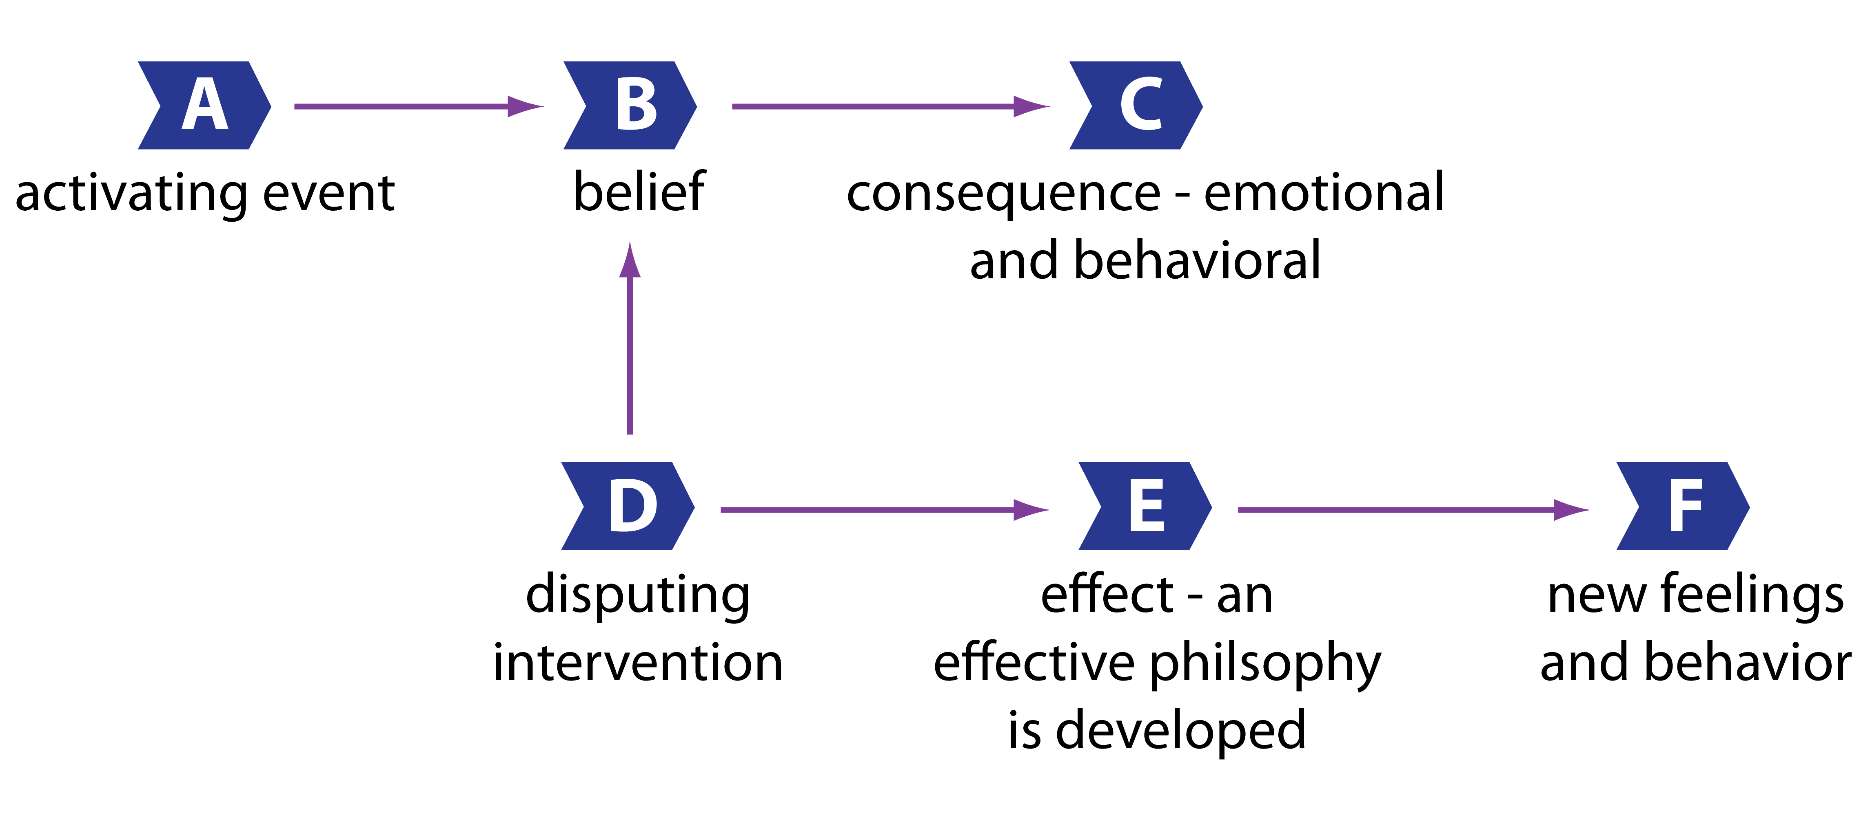

Now consider, changing this up, by intervening or disputing that faulty way of thinking. Go to the examples with the presentation, and the people going out. Choose one of these three scenarios.

Post Therapy or With Intervention
- What was the activating event in this example? __________________________________________________________________________________________________________________________________________________________________________________________
- B. What is the potential belief given in this example? __________________________________________________________________________________________________________________________________________________________________________________________
- What are they saying is a possible consequence based on this belief or way of thinking?
__________________________________________________________________________________________________________________________________________________________________________________________

- What is be one disputing intervention or way of looking at this differently?
__________________________________________________________________________________________________________________________________________________________________________________________
- How would this help the situation?
__________________________________________________________________________________________________________________________________________________________________________________________

What is the main point of this type of therapeutic approach?
__________________________________________________________________________________________________________________________________________________________________________________________
____________________________________________________________________________________________________________________________________________________________________________________________________________________________________________________________________________________________________________________________________________________________________________________

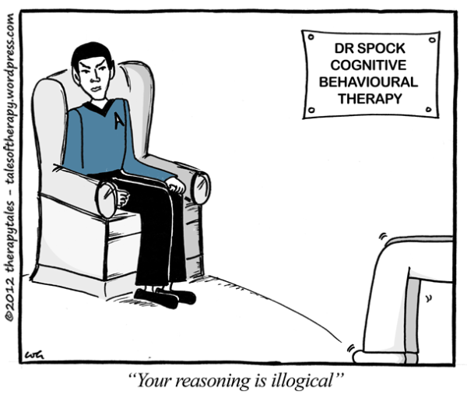
CBTandFeelingGood.com – Handout – A Blank ABCD form guide…
Reminder – We identify our bad feelings, then link the event/situation, then identify the thoughts, then dispute …
Tips for disputing: What is the evidence? What alternative views are there? What is the effect of thinking the way I do? Is my thinking realistic? What would I tell my best friend?

Task: Fill in your own personal ABCD form

A = Activating Event | B = Belief/thought | C = Consequence feelings | D = Dispute

